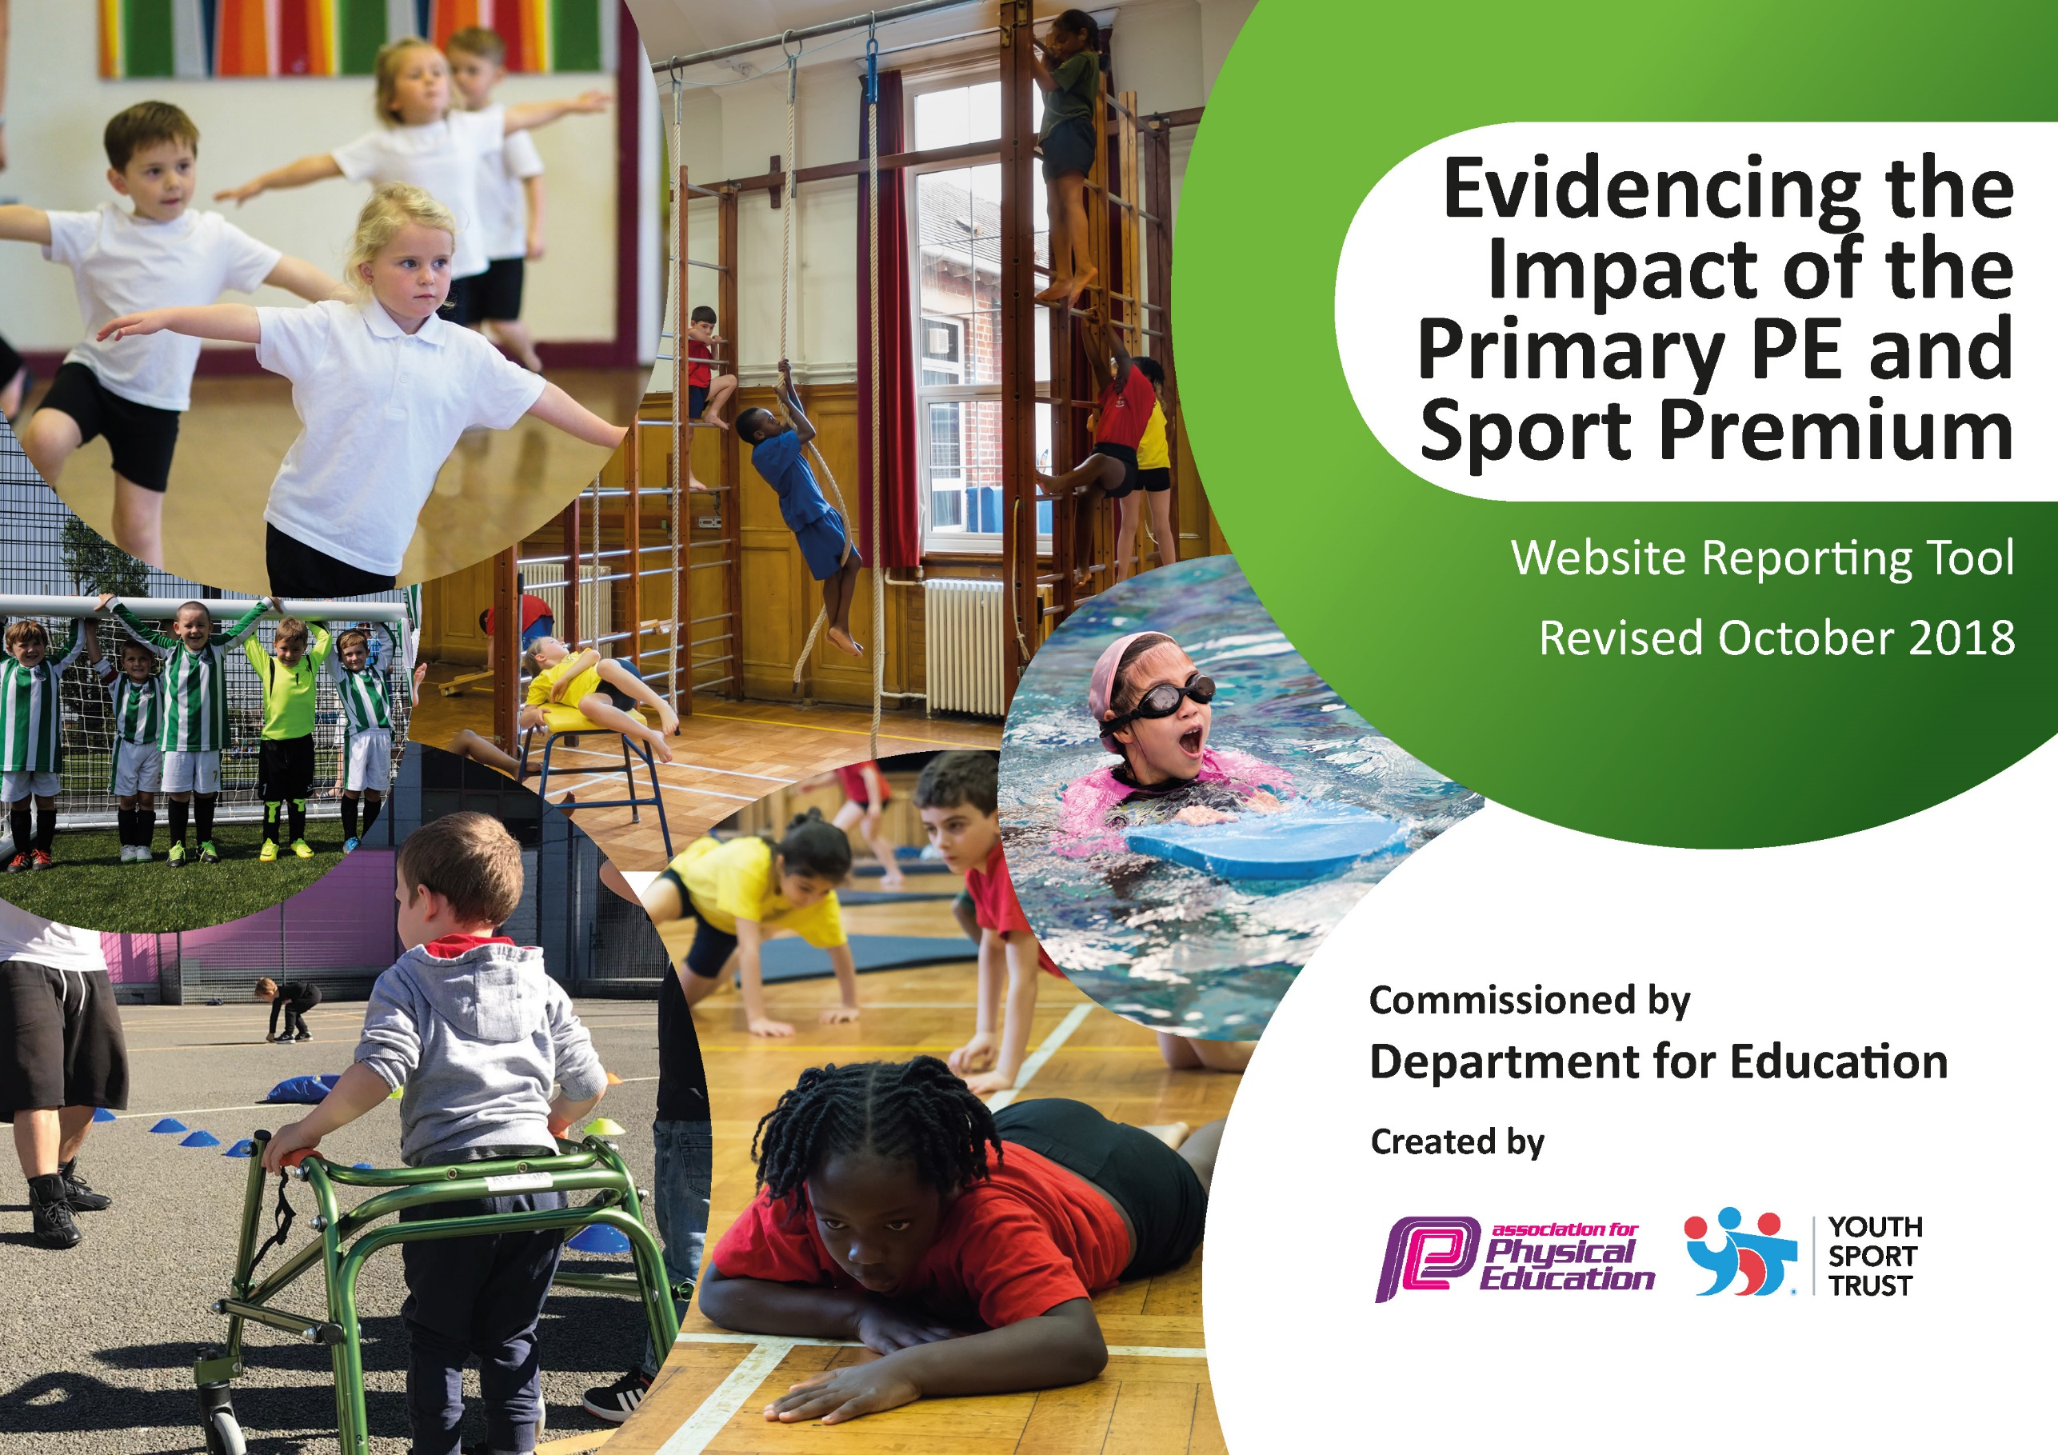
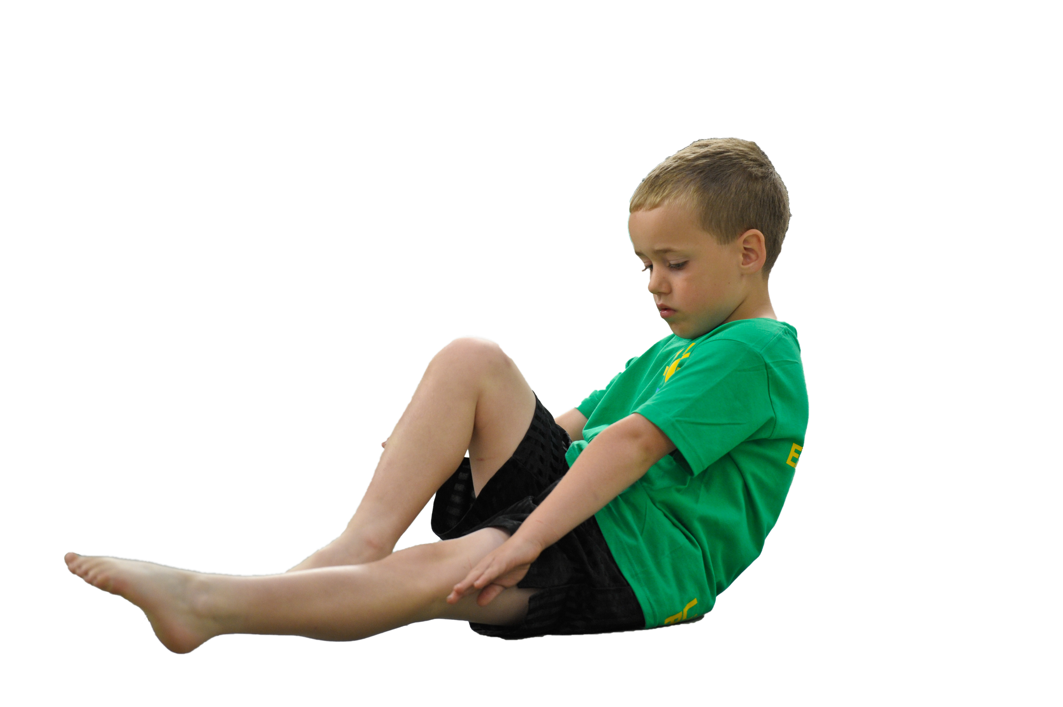
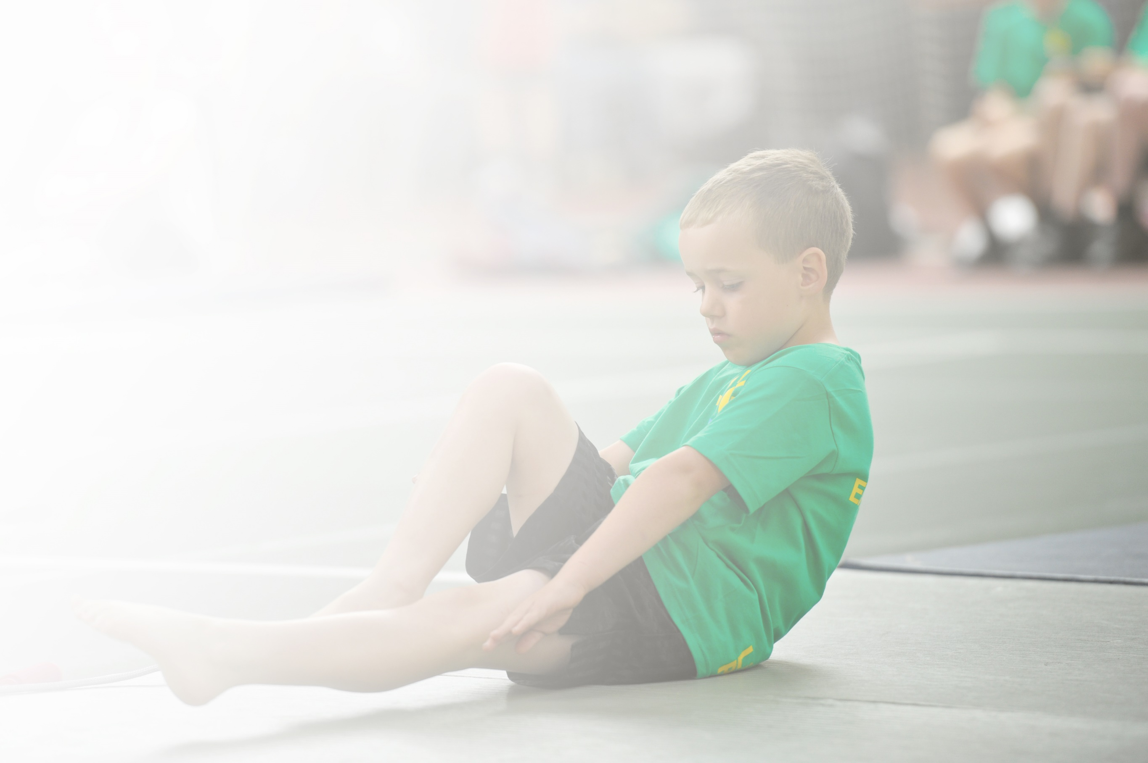
Schools must use the funding to make additional and sustainable improvements to the quality of Physical Education, Sport and Physical Activity (PESPA) they offer. This means that you should use the Primary PE and Sport Premium to:

- Develop or add to the PESPA activities that your school already offer
- Build capacity and capability within the school to ensure that improvements made now will benefit pupils joining the school in future years

Please visit gov.uk for the revised DfE guidance including the 5 key indicators across which schools should demonstrate an improvement. This document will help you to review your provision and to report
your spend. DfE encourages schools to use this template as an effective way of meeting the reporting requirements of the Primary PE and Sport Premium.

We recommend you start by reflecting on the impact of current provision and reviewing the previous
spend. Under the Ofsted Schools Inspection Framework, inspectors will assess how effectively leaders use the Primary PE and Sport Premium and measure its impact on outcomes for pupils, and how effectively governors hold them to account for this.

Schools are required to publish details of how they spend this funding as well as on the impact it has on pupils’ PE and sport participation and attainment by the end of the summer term or by 31 July 2019 at the
latest.
We recommend regularly updating the table and publishing it
on your website throughout the year, as evidence of your
ongoing review into how you are using the money to
secure maximum, sustainable impact. To see an
example of how to complete the table please
click HERE.

Support for review and reflection - considering the 5 key indicators from DfE, what development needs are a priority for your setting and your students now and why? Use the space below to reflect on previous spend, identify current need and priorities for the future.

Key achievements to date: 2021-22 | Areas for further improvement and baseline evidence of need:
- Covid 19 continued to restrict events during 2021 which curtailed most plans  - Key worker children accessed fit4fun/Tiger’s Trust (spring Term) other children home educated accessed on line learning included Jo Wicks, Yoga etc enabling an emphasis on health and fitness despite lockdown. All children were able to access these organisations at some point during the year. | - Increase the percentage of KS1 and KS2 pupils attending after school sporting clubs.  - Explore development of sport without permanently employed sports mentor - use of different organisations to diverse our sports base and increase participation rates  - Make playtimes and lunchtimes more active, with a focus on movement for fun – purchase equipment to allow this.

Meeting national curriculum requirements for swimming and water safety | Please complete all of the below:
What percentage of your current Year 6 cohort swim competently, confidently and proficiently over a distance of at least 25 metres?  N.B. Even though your children may swim in another year please report on their attainment on leaving  primary school. | %
What percentage of your current Year 6 cohort use a range of strokes effectively [for example, front crawl, backstroke and breaststroke]? | %
What percentage of your current Year 6 cohort perform safe self-rescue in different water-based situations? | %
Schools can choose to use the Primary PE and Sport Premium to provide additional provision for swimming but this must be for activity over and above the national curriculum requirements. Have you used it in this way? | Yes – we have additional swimming lessons set up for the autumn term and the spring term. This will provide catch-up for those who missed lessons due to lockdowns.

Action Plan and Budget Tracking
Capture your intended annual spend against the 5 key indicators. Clarify the success criteria and evidence of impact that you intend to measure to evaluate for students today and for the future.

Academic Year: 2021/22 | Total fund allocated:20,000 + 5,508 (Carried forward 20/21) spent(25,363) | Date Updated: July 2021
Key indicator 1: The engagement of all pupils in regular physical activity – Chief Medical Officer guidelines recommend that primary school children undertake at least 30 minutes of physical activity a day in school |  |  |  | Percentage of total allocation:
 |  |  |  | 78%
School focus with clarity on intended impact on pupils: | Actions to achieve: | Funding allocated: | Evidence and impact: | Sustainability and suggested next steps:
Employ sports coaches to provide additional opportunities, enhance staff skills, provide additional lunchtime and after school clubs  Tigers Trust  Fit4Fun  Catch-up swimming lessons for current Year 5 and 6.  Membership of Humber sports partnership and active Withernsea | To allow staff to confidently be able to deliver consistently high quality PE and Games lessons and maintain progression of skills across the curriculum and increase opportunities within and out of school day for sport participation  Improve percentage of swimmers hindered through lockdown and covid restrictions  Make movement fun, community involved and links with the High school. Aim to get all children more active both in and out of school. | £4,500  £5,000  £8,500  £2,000
Key indicator 2: The profile of PESSPA being raised across the school as a tool for whole school improvement |  |  |  | Percentage of total allocation:
 |  |  |  | 7%
School focus with clarity on intended impact on pupils: | Actions to achieve: | Funding allocated: | Evidence and impact: | Sustainability and suggested next steps:
imoves resource  Enable all pupils to participate in PE and games. | Creates an active school by supporting staff to deliver active lessons from literacy to science.  Purchase spare PE kits for every class throughout the school. | £1,000  £300

Key indicator 3: Increased confidence, knowledge and skills of all staff in teaching PE and sport and ensure PE leader in a good position to support PE development across school |  |  |  | Percentage of total allocation:
 |  |  |  | 1 %
School focus with clarity on intended  impact on pupils: | Actions to achieve: | Funding  allocated: | Evidence and impact: | Sustainability and suggested  next steps:
afPE membership to ensure access to specialist and expert support for all staff to keep up to date with key issues  CPD available from Tigers Trust to support staff  CPD available from FIT4FUN to support staff. | Increase awareness of the subject through journals.  Questionnaires to establish areas of least confidence.  Staff to use lessons and ideas from outside agencies to improve lesson delivery. | £113  Within package (no additional cost)
Key indicator 4: Broader experience of a range of sports and activities offered to all pupils |  |  |  | Percentage of total allocation:
 |  |  |  | 12%
School focus with clarity on intended  impact on pupils: | Actions to achieve: | Funding  allocated: | Evidence and impact: | Sustainability and suggested  next steps:
Additional achievements:  Intra House Sports Week – every year group takes part in different activities throughout the week in the summer.  Lunchtime/playtime equipment to encourage children to move for fun.  After School Clubs run all year round and are on offer for KS1 and KS2. They change every term based on a questionnaire completed by the children.  Dodgeball, netball, football, multi skills, boccia, kurling, judo, gymnastics | Offers an opportunity for those children who normally disengage with PE or sports and may encourage them to become more active. Also gives the sporty children an opportunity to try their skills in a different area of sports they may not have tried before.  Provide a variety of different activities for all children to enjoy and become more active.  Increase participation by offering a  Variety of different activities. | FREE  £1,500  Subsidy  Dodgeball cover  £500  High sch hall £300
Key indicator 5: Increased participation in competitive sport |  |  |  | Percentage of total allocation:
 |  |  |  | 7%
School focus with clarity on intended  impact on pupils: | Actions to achieve: | Funding  allocated: | Evidence and impact: | Sustainability and suggested  next steps:
More children to represent the school in competitive sports.  Transport Costs  Reward children with medals/trophies | HCAT Competitions  Tigers Trust Competitions  Humber sports partnership  To travel to competitions  Travel to outdoor activity centre  Children feel proud and part of a team. | £1,500  £150

